 **University of**

**Tennessee System**

**Chief Financial Officer**

**The University of Tennessee**

**POSITION SPECIFICATION**

**Summer 2016**

**THE OPPORTUNITY**

The University of Tennessee System invites applications and nominations for the position of Chief Financial Officer (CFO). The position reports to the President of the statewide University System and is an officer elected by the Board of Trustees. The CFO is accountable for the administration of all financial operations of the University, including development and monitoring of control systems designed to preserve company assets, report accurate financial results, monitor adherence to the budget and develop long-term financial and operational strategies.

The CFO shall assist the President in the active management of the University and shall perform such specific duties as from time to time may be prescribed by the President, the Board or by any standing or special committee of the Board.

There is a collaborative relationship with the chief financial officers at each campus and institute. The CFO should be able to operate effectively in the distributed and highly transactional environment that characterizes the complex university system.

**THE POSITION**

The CFO will develop and implement a financial vision for the University congruent with the mission and objectives of the campuses and institutes. Systems responsibilities include the budgeting, accounting and reporting for all operations; information technology and the University’s ERP system; investment of University operating and endowment funds; and the capital outlay and maintenance programs. The CFO will receive and shall have custody of all monies which shall come to the University for the purposes of the University and shall be responsible for the proper handling of such funds in accordance with applicable state statutes and with policies set by the Board of Trustees. The CFO shall give bond in the amount determined by the Board of Trustees, the premium on which shall be paid by the University. The CFO will communicate and build relationships with elected officials, board members, state constitutional officers, THEC staff, other University staff and business and community leaders while ensuring fiscal accountability and adherence to the appropriate constraints.

The CFO staffs the Finance and Administration Committee and the Health Affairs Committee of the Board of Trustees. Units that currently report specifically to the CFO include: accounting, accounts payable, cash management, contracts administration, financial reporting, flight operations, human resources, information technology services, investments, IRIS administrative support, payroll, purchasing, risk management, system budget office and trademark licensing.

For information on how to refer potential candidates, to express personal interest or to obtain additional information about the position, please see the section titled “Procedure for Candidacy” near the end of this document.

**THE UNIVERSITY OF TENNESSEE SYSTEM: AN OVERVIEW**

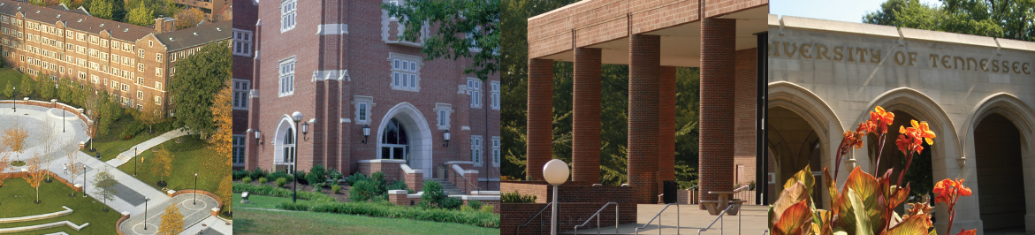

The University of Tennessee is the state’s land-grant, higher education institution and flagship public university. It is comprised of campuses at [Knoxville](http://www.utk.edu/), [Chattanooga](http://www.utc.edu/), and [Martin](http://www.utm.edu/); the [Health Science Center](http://www.uthsc.edu/) at Memphis; the [Space Institute](http://www.utsi.edu/) at Tullahoma; and the statewide [Institute of Agriculture](https://ag.tennessee.edu/Pages/default.aspx) and [Institute for Public Service](http://ips.tennessee.edu/).

The University of Tennessee System has a presence in each of the state’s 95 counties. Through the combined force of its education, research, and outreach, the University serves students, business and industry, schools, governments, organizations, and citizens throughout Tennessee.

Statewide, UT provides a range of accessible and affordable educational opportunities at the undergraduate and graduate levels and operates highly regarded professional schools. About 49,000 students are enrolled statewide and more than 10,000 graduate each year. Approximately 362,000 alumni live throughout the state, nation and world.

The [UT System Administration Strategic Plan](http://president.tennessee.edu/strategicplan), launched in June 2012 and updated in 2015, establishes a vision and direction with the following clearly defined goals to ensure good stewardship and purposeful use of resources:

1. [Enhancing educational excellence](http://tennessee.edu/static/strategicplan/dashboard/goal1.html#start)

2. [Expanding research capacities](http://tennessee.edu/static/strategicplan/dashboard/goal2.html#start)

3. [Fostering outreach and engagement](http://tennessee.edu/static/strategicplan/dashboard/goal3.html#start)

4. [Ensuring effectiveness and efficiency](http://tennessee.edu/static/strategicplan/dashboard/goal4.html#start)

5. [Advocating for the University of Tennessee System](http://tennessee.edu/static/strategicplan/dashboard/goal5.html#start)

**History**

The University of Tennessee is the [state’s oldest and largest](http://tennessee.edu/history/) public higher education institution. It traces its beginnings to the founding of Blount College in Knoxville in 1794, two years before Tennessee became a state. The UT System was formed in 1968.

Please see Appendix II and III of this document for more information on the University and the Knoxville community.

**Governance**

The [UT Board of Trustees](http://trustees.tennessee.edu/) is the governing body overseeing the educational and operational activities of the statewide University system. The 26-member board is comprised of five *ex officio* members and 21 members appointed by the governor. The appointed seats include one voting and one non-voting faculty member, one voting and one non-voting student, and 17 congressional district and county representatives.

The governor serves as an *ex officio* voting member of the board and, by election, as chair. Both the chair and vice chair are elected by the board at its annual meeting in June and serve for two-year terms. Other *ex officio* members include the President of the UT System, the Commissioner of Agriculture and the Commissioner of Education for the state of Tennessee, and the executive director of the Tennessee Higher Education Commission (a non-voting seat).

The UT System’s general counsel serves as secretary of the University and principal staff liaison to the UT Board of Trustees. Standing committees of the board include: academic affairs and student success; advancement and public affairs; audit and compliance; executive and compensation; finance and administration; health affairs, trusteeship; and research, outreach, and economic development. The President serves as a voting member of the board and as a non-voting member of all committees, except the audit and compliance committee.

**University Budget**

The university’s proposed budget is $2.2 billion for the fiscal year beginning July 1, 2016. UT’s three major sources of revenue (tuition and fees, state appropriations, and grants and contracts) account for 80% of total revenues. State appropriations provide 25% of total revenues, tuition and fees account for 30%, and grants and contracts generate 25%. Self-funded auxiliaries such as housing, food services, bookstores, and athletics generate 11%. The remaining 9% comes from gifts, endowments, investments, sales of educational services, and other miscellaneous sources.

The state’s flagship campus in Knoxville generates 50.5% of total revenues. The Health Science Center, which is headquartered in Memphis but operates educational and clinical programs statewide, accounts for 21.8% ($479.5 million). UT Chattanooga has experienced dramatic growth in enrollment and now generates 10.2% of total UT revenues ($225.4 million). UT Martin accounts for 6.6% ($144.8 million). The Institute of Agriculture makes up 8.2% ($181.6 million). The Institute for Public Service, UT Space Institute in Tullahoma, and System Administration account for the remaining 2.7% of UT revenues.

About one-third of all expenditures are for instruction. Research accounts for 12% of total expense and public service makes up 7%. Scholarships and fellowships have been the fastest growing expense category over the last few years

and now accounts for 13% of total spending. Student services and academic support,

which includes libraries, are 12%. Facilities, institutional support, and self-funded

auxiliaries make up the remainder.

An almanac of University data is available at:

<http://www.tennessee.edu/system/academicaffairs/institutional_research/facts_figures.html>

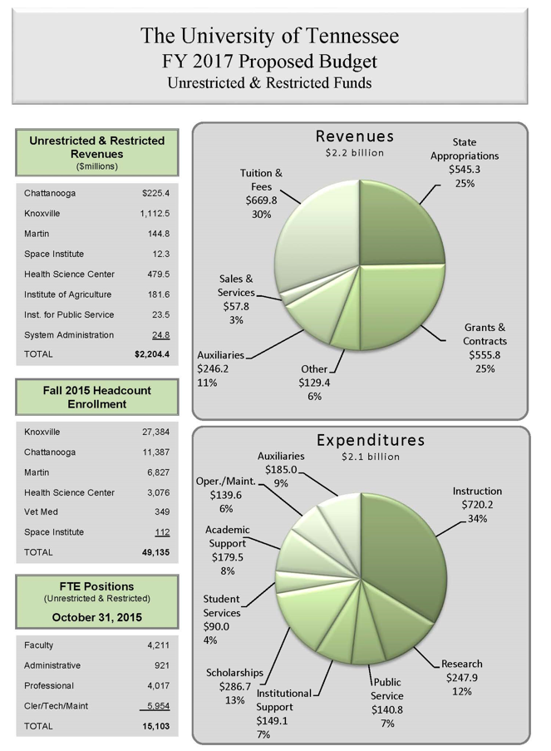

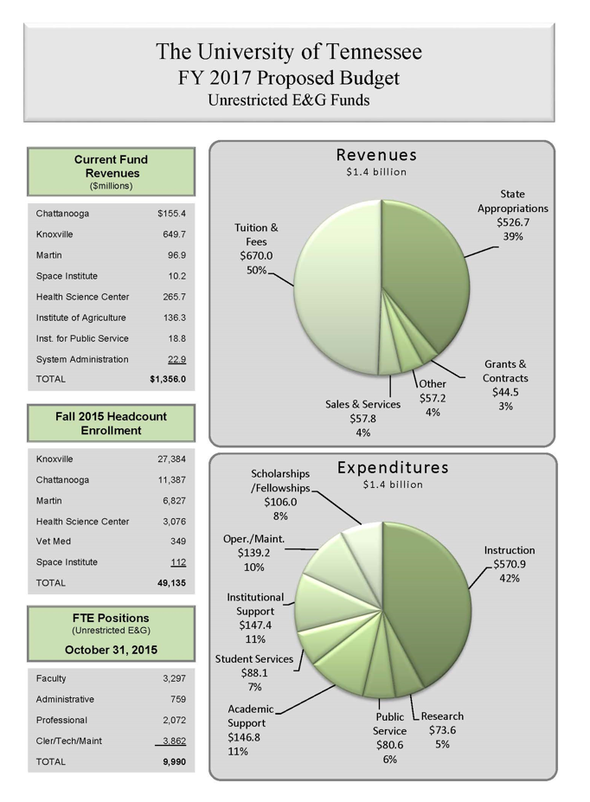

**THE ROLE**

The CFO reports to the President of the University System and is an officer elected by the Board of Trustees. The CFO is accountable for the administration of all financial operations of the University, including development and monitoring of control systems designed to preserve company assets, report accurate financial results, monitor adherence to the budget and develop long-term financial and operational strategies.

The CFO shall assist the President in the active management of the University and shall perform such specific duties as from time to time may be prescribed by the President, the Board or by any standing or special committee of the Board.

The CFO will develop and implement a financial vision for the University congruent with the mission and objectives of the campuses and institutes. Systems responsibilities include the budgeting, accounting and reporting for all operations; information technology and the University’s ERP system; investment of University operating and endowment funds; and the capital outlay and maintenance programs. The CFO will receive and shall have custody of all monies which shall come to the University for the purposes of the University and shall be responsible for the proper handling of such funds in accordance with applicable state statues and with the policies set by the Board of Trustees. The CFO shall give bond in the amount determined by the Board of Trustees, the premium on which shall be paid by the University. The CFO will communicate and build relationships with elected officials, board members, state constitutional officers, THEC staff, other University staff and business and community leaders while ensuring fiscal accountability and adherence to the appropriate constraints.

The CFO staffs the Finance and Administration Committee and the Health Affairs Committee of the Board of Trustees. Units that currently report specifically to the CFO include: accounting, accounts payable, cash management, contracts administration, financial reporting, flight operations, human resources, information technology services, investments, IRIS administrative support, payroll, purchasing, risk management, system budget office and trademark licensing.

The University of Tennessee is seeking candidates who have the ability to contribute in meaningful ways to the diversity and intercultural goals of the University.

Please see Appendix I for the Organizational Chart.

**QUALITIES AND QUALIFICATIONS**

The position requires a Bachelor’s degree in a related field. Prefer advanced degrees and professional certifications (MBA, MAcc, Certified Public Accountant and/or Certified Management Accountant).

The position requires a minimum of ten years of progressively responsible financial and administrative experience in a large and complex organization. Experience in a multi-campus university system would be helpful, but is not required. Position requires demonstrated knowledge of methods of allocating scarce resources and the attendant revenue enhancing models, strong leadership skills and the ability to communicate effectively with various constituencies of the University. The CFO will have experience managing finance (accounting, budgeting, risk management, human resources, control and reporting) for a complex nonprofit with multiple funding sources including government (federal and state) contracts and an affiliate structure with diverse program areas.

The successful candidate will demonstrate:

* innovation and resourcefulness
* ability to collaborate
* ability to lead by influence
* an honest and direct communication style
* strong leadership skills
* a proven track record of quality and integrity
* expertise in current financial methodology and regulations
* significant experience in or knowledge of GASB accounting, including sophisticated fund and grant accounting, compliance and reporting
* knowledge of and commitment to affirmative action and equal employment opportunity
* knowledge of establishing metrics, including analysis of leading and lagging indicators
* ability and willingness to delegate effectively and to hold direct reports accountable
* strong skills in communications and interpersonal relations
* strong decision-making skills, with transparency in decision-making and management
* excellent oral, written and presentation skills; exceptional listening skills
* ability to multi-task and to travel frequently

The Chief Financial Officer will exhibit qualities of emotional maturity, genuineness, self-confidence, common sense, judgment, fairness, creativity, discretion, decisiveness, political savvy, diplomacy, tact, resiliency, adaptability, courage of convictions, and tolerance for ambiguity. Demonstrated behavioral expectations include:

* unquestioned integrity and trustworthiness
* fiscally minded
* results-driven
* committed to return on investment/value
* committed to the University’s mission and strategic plan, as well as missions and strategic plans for each campus/institute
* ability to make good, consistent and fair decisions (based on fact and data)
* ability to work with cross-functional teams and to foster teamwork

**PROCEDURE FOR CANDIDACY**

Recruitment will continue until the position is filled. Information specifically on this search may be found at: <https://ut.taleo.net/careersection/ut_system/jobdetail.ftl?job=16000000UG>

Confidential review of materials will begin immediately with the Search Committee meeting on August 11, 2016 to select candidates for airport interviews. To make a referral, to express interest in the position or to obtain additional information, please contact:

Ashlie Czyz, Executive Recruiter  
University of Tennessee System

105 Student Services Building, 1331 Circle Park Drive

Knoxville, TN 37996

Phone 865/974-1907

[**aczyz@tennessee.edu**](mailto:aczyz@tennessee.edu)

Please note that the state of Tennessee prides itself on the transparency of its government, and all formal candidacies will be a subject to public inquiry.

The University of Tennessee is an EEO/AA/Title VI/Title IX/Section 504/ADA/ADEA institution in the provision of its education and employment programs and services. All qualified applicants will receive equal consideration for employment without regard to race, color, national origin, religion, sex, pregnancy, marital status, sexual orientation, gender identity, age, physical or mental disability, or covered veteran status.

**APPENDIX I — ORGANIZATIONAL CHART**



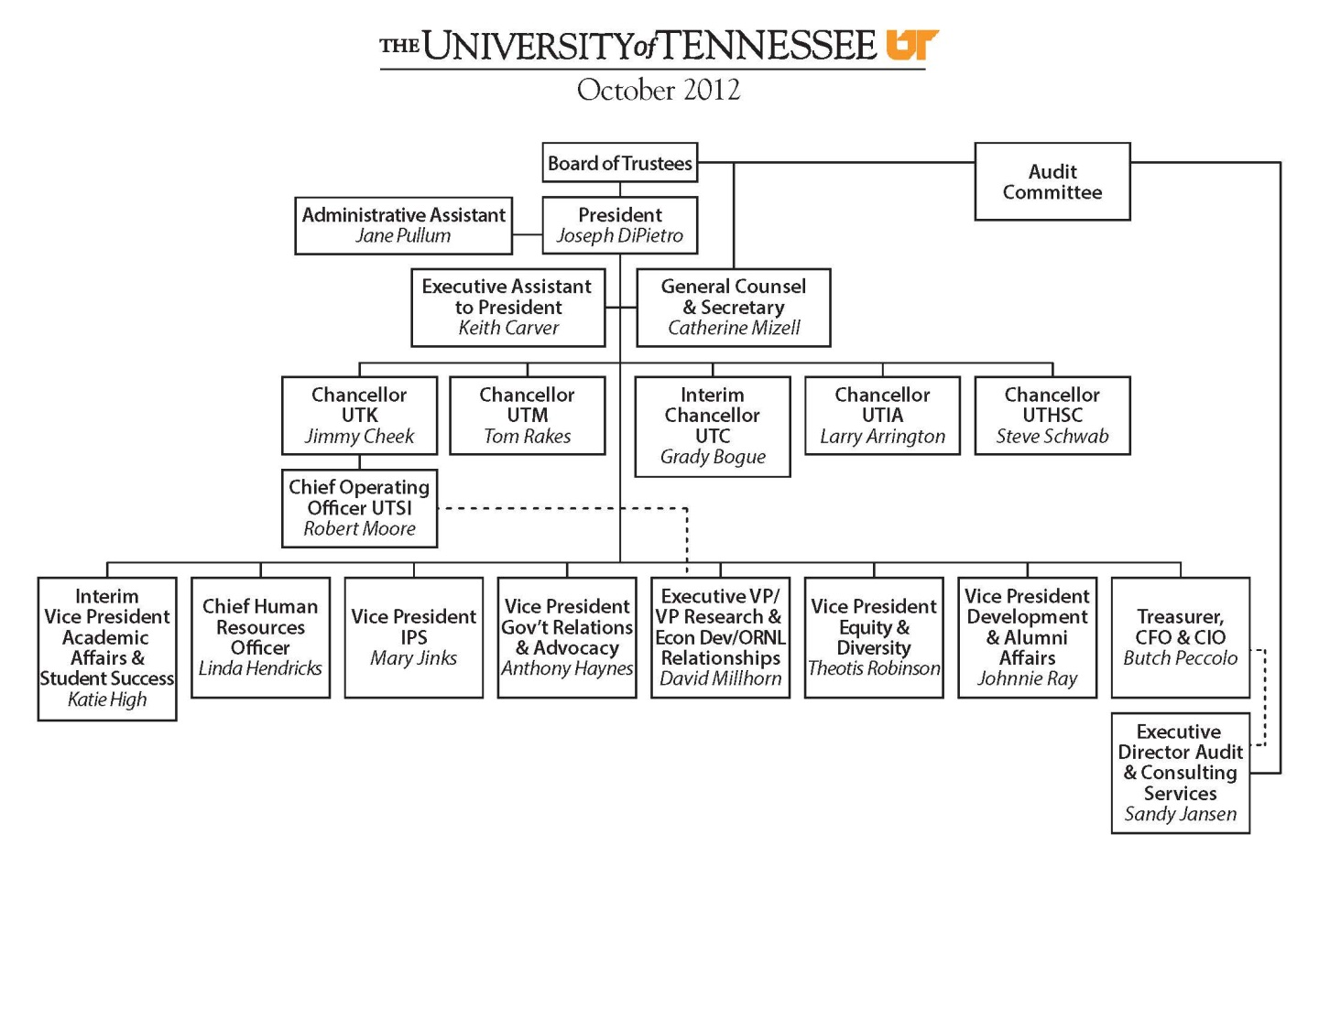

1

**APPENDIX II — UNIVERSITY INFORMATION**

**Partnership with the Oak Ridge National Laboratory**



The UT System is a managing partner, through UT-Battelle, of Oak Ridge National Laboratory (ORNL) – home to the largest open-science research facility in the national laboratory system. This partnership provides UT a unique opportunity to be at the forefront of solving some of the nation’s and the world’s greatest challenges.

The UT-Oak Ridge Partnership, with a focus on computational science, neutron science, biological sciences, nanomaterials and advanced materials is an unparalleled resource for the state.

More about the UT-Oak Ridge Partnership is at: <http://www.tennessee.edu/ornl>.

**Cherokee Farm**

Cherokee Farm, UT’s multi-use, high-technology research center located near the UT Knoxville campus, is a platform for world-class academic and economic partnership.

Cherokee Farm positions UT and the state as one of the world’s most competitive areas for collaborative research. Drawing on leadership roles already established by UT-ORNL joint institutes in computational science, neutron science, biological sciences, nanomaterials and advanced materials, Cherokee Farm also will be a center for research in alternative energy and environmental sustainability. Cherokee Farm scientists and public and private partners will form an interdisciplinary research hub committed to solving problems of global significance.

More about Cherokee Farm may be found at: <http://www.tennessee.edu/system/cherokee>.

**The State of Tennessee**

Tennessee is a state with more than 6.3 million people, four large metropolitan areas, two time zones, and an economy ranked* 17th-largest in the United States. While more Tennessee jobs and economic activity today are industrial or knowledge-based than agrarian, farming and agricultural production remain fundamental to the state’s economy. Major outputs include textiles, cotton, cattle, and electrical power – thanks to being home to TVA.

From the Mississippi River on the western border, to the Appalachian Mountains on the eastern border, Tennessee spans a distance of more than 400 miles. Major geographic and cultural diversity are evident from the delta and farm areas of the west, to the rolling hills surrounding Nashville in Middle Tennessee, to the mountainous landscape of East Tennessee.

The state’s four largest cities are Memphis, metropolitan area population: 1.3 million; Nashville, metropolitan area population: 1.5 million; Knoxville, metropolitan area population: almost 700,000; and Chattanooga, metropolitan area population: about 500,000.

Major corporations headquartered in Tennessee include FedEx, AutoZone, International Paper, all based in Memphis; Pilot Corp., Scripps Networks Interactive, and Regal Entertainment Group based in Knoxville; Eastman Chemical based in Kingsport; Nissan’s North American headquarters in Franklin; and the headquarters of Caterpillar Financial, Bridgestone-Firestone and HCA all based in Nashville. A large Nissan manufacturing facility has been in Smyrna since 1982. In 2015, Volkswagen announced a $17.8 million expansion of its major manufacturing facility in Chattanooga.

The University of Tennessee maintains a presence in, draws students from and boasts alumni in each of Tennessee’s 95 counties. Collectively, the entire state is the campus, and overseeing all UT enterprises and maintaining relationships with the University’s numerous constituencies statewide is the responsibility of the UT System president.

*\*Source: U.S. Bureau of Economic Analysis 2015*

**APPENDIX III—The Knoxville Community**



Knoxville is the home of both the UT System offices and UT Knoxville campus. Knoxville is a 90-minute drive to the UT Chattanooga campus, a two-and-a-half-hour drive to the state capital in Nashville, a five-and-a-half-hour drive to the UT Martin campus and a six-hour drive to the Health Science Center in Memphis.

Knoxville is both the oldest and the third-largest city in the state of Tennessee; only Memphis and Nashville are larger. Nestled in the foothills of the Appalachian Mountains along the Tennessee River, Knoxville is a one-hour drive from Great Smoky Mountains National Park, the U.S. National Park Service’s most-visited site. Knoxville also is within a day’s drive or less to many major metropolitan areas, including Atlanta, Chicago, Washington, D.C. and the Atlantic coast.

Knoxville boasts a vibrant history, captured in the works of nationally renowned poets, writers and artists, including James Agee, Cormac McCarthy and Nikki Giovanni.

More about Knoxville and links to numerous related websites may be found at:

[http://www.utk.edu/knoxville/.](http://www.utk.edu/knoxville/)