CHANCELLOR

POSITION SPECIFICATION

THE OPPORTUNITY

The University of Tennessee invites applications for the position of Chancellor of the University of Tennessee-Knoxville campus. The Chancellor is the Chief Executive Officer for the campus, a land-grant Carnegie university with highest research activity. Reporting to the President of the UT System, this position is fully responsible for the leadership and management of the campus, including its athletics program. The Chancellor aggressively promotes continued development of the campus’ academic programs, research productivity, and national reputation of excellence.

THE UNIVERSITY OF TENNESSEE, KNOXVILLE: AN OVERVIEW

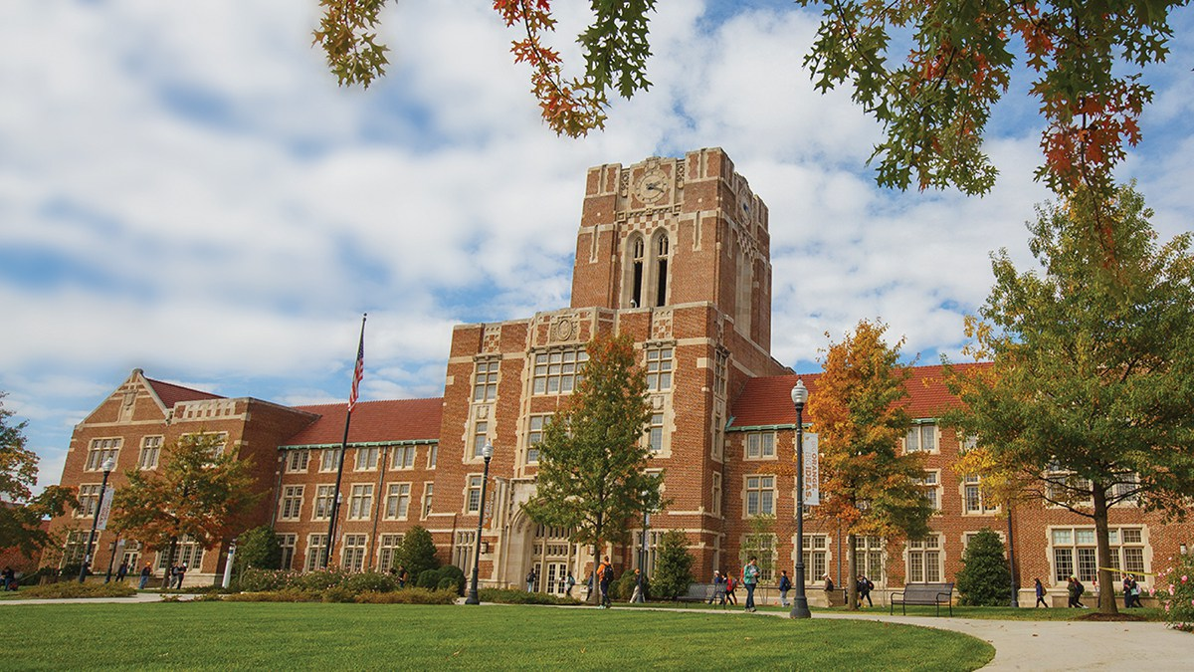
Founded in 1794, UT is big on tradition, and we are proud of our history as the first public university chartered west of the Appalachian Divide. We serve the state of Tennessee by educating its citizens, enhancing its culture, and making a difference in people’s lives through research and service. Since 1897, the University of Tennessee, Knoxville has been continuously accredited by the Southern Association of Colleges and Schools Commission on Colleges to award baccalaureate, master’s, and doctoral degrees. The University has 27,845 students, over 1700 instructional faculty, 11 academic colleges and over 300 degree programs.
UT Knoxville is:
- Tennessee’s flagship land-grant university
- A public research institution
- Part of the UT System, along with UT Chattanooga, UT Martin, UT Institute of Agriculture, UT Health Science Center, the UT Institute of Public Service and the UT Space Institute
- Classified by the Carnegie Foundation as a Research University (highest research activity)
- A Carnegie Engaged University
- Governed by a UT System Board of Trustees with twenty-six members
MISSION
The primary mission of the University of Tennessee is to move forward the frontiers of human knowledge and enrich and elevate the citizens of the state of Tennessee, the nation, and the world. As the preeminent research-based land-grant university in the state, UT embodies the spirit of excellence in teaching, research, scholarship, creative activity, outreach, and engagement attained by the nation’s finest public research institutions.
VISION
The University of Tennessee seeks to become a top tier public research university. Inherent in this vision is an acknowledgement that UT is currently a premier institution. Our vision reflects a desire to contribute to the legacy of the University and its longstanding tradition of excellence.
Our journey is one with an ambitious goal – to join the ranks of the nation’s top public research universities. An aggressive roadmap and strategic plan named Vol Vision 2020 guides our journey. Since we began our journey in 2010, we have made great strides in improving our students’ experiences and outcomes while making new discoveries and engaging with our local and global communities. Through our leadership in innovation and economic development, progress has also made a significant difference for the citizens of the state of Tennessee. Every day we become a better institution, which helps us become an even better investment for our students and the state. For more information about our journey and Vol Vision 2020, see http://top25.utk.edu/.

The State of Tennessee
Tennessee is a state with more than 6.3 million people, four large metropolitan areas, two time zones, and an economy ranked* 17th-largest in the United States. While more Tennessee jobs and economic activity today are industrial or knowledge-based than agrarian, farming and agricultural production remain fundamental to the state’s economy. Major outputs include textiles, cotton, cattle, and electrical power – thanks to being home to TVA.

The University of Tennessee maintains a presence in, draws students from and boasts alumni in each of Tennessee’s 95 counties. Collectively, the entire state is the campus, and overseeing all UT enterprises and maintaining relationships with the University’s numerous constituencies statewide is the responsibility of the UT System president.

From the Mississippi River on the western border, to the Appalachian Mountains on the eastern border, Tennessee spans a distance of more than 400 miles. Major geographic and cultural diversity are evident from the delta and farm areas of the west, to the rolling hills surrounding Nashville in Middle Tennessee, to the mountainous landscape of East Tennessee.

The state’s four largest cities are Memphis, metropolitan area population: 1.3 million; Nashville, metropolitan area population: 1.5 million; Knoxville, metropolitan area population: almost 700,000; and Chattanooga, metropolitan area population: about 500,000.
Major corporations headquartered in Tennessee include FedEx, AutoZone, International Paper, all based in Memphis; Pilot Corp., Scripps Networks Interactive, and Regal Entertainment Group based in Knoxville; Eastman Chemical based in Kingsport; Nissan’s North American headquarters in Franklin; and the headquarters of Caterpillar Financial, Bridgestone-Firestone and HCA, all based in Nashville. A large Nissan manufacturing facility has been in Smyrna since 1982. In 2015, Volkswagen announced a $17.8 million expansion of its major manufacturing facility in Chattanooga.

The Knoxville Community

Nestled in the foothills of the Appalachian Mountains along the Tennessee River, Knoxville is a thriving Southern city known for its great outdoors, diverse music scene, and wide variety of eateries. It is nationally known for its Urban Wilderness, located less than three miles from downtown, with more than 50 miles of natural trails. A vibrant downtown, located less than a mile from the heart of the UT campus, offers live entertainment, unique shopping and outstanding local dining and brews.

With a population at nearly 852,000 in the Knoxville Metropolitan area, it is both the oldest and the third-largest city in the state of Tennessee; only Memphis and Nashville are larger. Knoxville is a one-hour drive from Great Smoky Mountains National Park, the U.S. National Park Service’s most-visited site. Knoxville also is within a day’s drive or less to many major metropolitan areas, including Atlanta, Chicago, Washington, D.C., and the Atlantic coast. UT’s Neyland Stadium is one of the country’s largest sports venues.

Knoxville #8 in "America's Favorite Places" by Travel & Leisure, #2 in “Most Affordable Cities” by Forbes, #5 for “Best Cities for Small Business” by CNN Money, and a Top 10 “Destination on the Rise” by Trip Advisor.

Partnership with the Oak Ridge National Laboratory

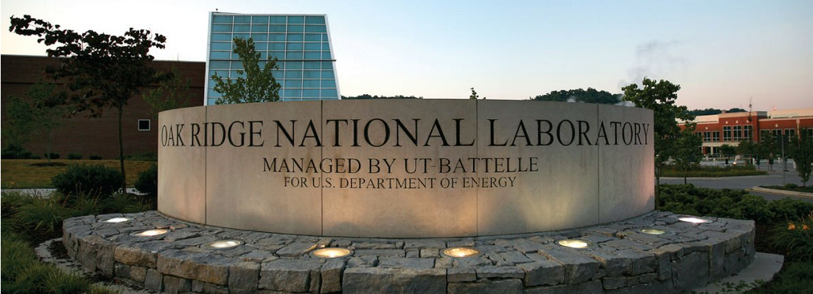

The UT System is a managing partner, through UT-Battelle, of Oak Ridge National Laboratory (ORNL) – the largest open-science research facility in the US Department of Energy’s National Laboratory System. The partnership provides UT unique opportunities at the forefront of efforts to solve some of the world’s greatest challenges in clean energy, nuclear security, scientific discovery, and environmental stewardship.

Joint faculty agreements are in place for 167 ORNL employees and 42 UT-Knoxville faculty, including 14 Governor’s Chairs who are leaders in the fields of advanced manufacturing, advanced materials, biological sciences, energy sciences, nuclear security, and urban design. The Governor’s Chair program, funded by the lab and the state of Tennessee, seeks to attract up to 20 prominent scientists to UT-Knoxville.

UT-Knoxville and ORNL also operate five joint institutes, in advanced materials, biological sciences, computational sciences, heavy ion research, and neutron sciences. More than 150 graduate students from UT-Knoxville perform their research at ORNL, including 139 currently pursuing Ph.D.s at the Bredesen Center for Interdisciplinary Research and Graduate Education. Most recently, UT-Knoxville led the establishment of the Institute for Advanced Composites Manufacturing Innovation, a $259 million public-private partnership backed by the White House to accelerate advanced manufacturing.

The partnership of UT and ORNL is an unparalleled resource for the state, of unique benefit to students and staff, and a key differentiator as UT-Knoxville pursues status as a Top 25 public research university. Learn more at: http://www.tennessee.edu/ornl.

POSITION OVERVIEW

The Chancellor is fully responsible for the leadership and management of the campus and aggressively promotes continued development of its academic programs, research productivity, and national reputation of excellence.

The primary responsibilities of the position are to promote excellence in academics, research and outreach and to provide leadership and direction of the campus, including its athletics program. The Chancellor is responsible for planning, implementing and leading strong, progressive programs of excellence across the enterprise.

The Chancellor is expected to provide visionary leadership and strategic initiatives to enhance the standing of the University, advocacy and support for the generation of new knowledge, strengthening of high quality programs of instruction and learning, resource enhancement and accountability, shared governance, and enhancement of campus diversity and inclusion. In coordination with the UT System, the Chancellor establishes and maintains productive relationships on behalf of the University with state government, the Tennessee congressional delegation and federal agencies. The Chancellor also fosters positive interactions with and support from alumni, benefactors and the community at large. The Chancellor plays a key role in the University System management, through UT-Battelle, of nearby Oak Ridge National Laboratory.

The Chancellor`s cabinet includes the Provost and Senior Vice Chancellor; the Senior Vice Chancellor for Finance and Administration, Vice Chancellors for Athletics, Human Resources, Research and Engagement, Student Affairs, Development and Alumni Affairs, and Communications. Recent decisions to retire or return to the faculty create the opportunity for a new Chancellor to move forward deliberately in assembling their own leadership team

Leadership responsibilities include, but are not limited to,

- Articulate a strategic vision and long-term goals for the campus and strengthen the national reputation of the University;
- Provide continued direction and incentives for research, creative achievement, service and outreach;
- Foster interdisciplinary approaches to world class undergraduate and graduate education and research;
- Promote excellence and innovation in all mission areas;
- Nurture relationships with other University programs, with Oak Ridge National Laboratory, CNS Y-12 National Security Complex and other universities, agencies, organizations and private enterprises;
- Build strong relationships with elected and governmental officials;
- Maintain a cooperative and mutually beneficial relationship with the chancellors of other campuses in the UT System;
- Recruit, develop and retain excellent and diverse faculty, administrators, students and staff and build an inclusive campus community;
- Lead the campus’s development and alumni activities and boost private fundraising and alumni engagement;
- Improve campus infrastructure;
- Place emphasis on globalization and sustainability;
- Understand the role of collegiate athletics and promote and oversee the operation of a nationally respected program.

LEADERSHIP ATTRIBUTES AND QUALIFICATIONS

- Requires an earned terminal degree and evidence of scholarly, professional, or creative achievement commensurate with tenure as a full professor at a doctoral highest research activity university;
- Demonstrated contemporary experience leading a complex and comprehensive university and personal history of teaching, research and outreach commensurate with faculty status at a major research university;
- An understanding of UT Knoxville’s mission as a public, research, land-grant university;
- Demonstrated knowledge of and a history of commitment to diversity, inclusion, and multicultural education;
- Ability to represent the University effectively to external audiences, including government and alumni groups;
- Ability to work collegially with a wide variety of constituencies in forging successful partnerships;
- Demonstrated skill in securing extramural and private funding;
- Exceptional skills in communications and interpersonal relations.

BEHAVIORS

- Unquestioned integrity and trustworthiness;
- Ability to innovate and foster positive changes;
- Skilled decision-maker, with transparency in decision-making and management;
- Commitment to the University’s mission and strategic plan;
- Ability to make good, consistent and equitable decisions;
- Ability and willingness to delegate effectively and to hold others accountable;
- Ability to work with cross-functional teams and to foster teamwork.

APPLICATIONS AND NOMINATIONS

The Search Committee invites letters of nomination, applications (letter of interest, resume/CV and contact information for professional references) or expressions of interest to be submitted to the search firm assisting the University. Review of materials will begin immediately and continue until the appointment is made. It is preferred, however, that all nominations and applications be submitted prior to September 23, 2016.

Laurie C. Wilder, President
Porsha L. Williams, Vice President
Parker Executive Search
770-804-1996 ext: 109
pwilliams@parkersearch.com || eraines@parkersearch.com
Please note that the state of Tennessee prides itself on the transparency of its government, and all formal candidacies will be a subject to public inquiry.

The University of Tennessee is an EEO/AA/Title VI/Title IX/Section 504/ADA/ADEA institution in the provision of its education and employment programs and services. All qualified applicants will receive equal consideration for employment without regard to race, color, national origin, religion, sex, pregnancy, marital status, sexual orientation, gender identity, age, physical or mental disability, or covered veteran status.

