

Chancellor
University of Tennessee Institute of Agriculture

POSITION SPECIFICATION

Summer 2016

THE OPPORTUNITY

The University of Tennessee invites nominations and applications for the position of Chancellor of the University of Tennessee Institute of Agriculture. The Chancellor of the University of Tennessee Institute of Agriculture (UTIA) serves on the University of Tennessee leadership team, reporting directly to the President. The Chancellor is the chief academic and administrative officer for the Institute and is fully responsible for the administration and management of the Institute’s units. This position aggressively promotes continued development of its academic and educational outreach programs, research productivity and national reputation of excellence, built upon a commitment to access and diversity. The Chancellor performs such specific duties as from time to time may be prescribed or assigned by the President, the Board, or by any standing or special committee of the Board. Components of the Institute of Agriculture, which deliver both campus-based and state-wide programs, include UT Extension, UT AgResearch, the College of Agricultural Sciences and Natural Resources and the College of Veterinary Medicine. This position is appointed by the President and elected by the University’s Board of Trustees.

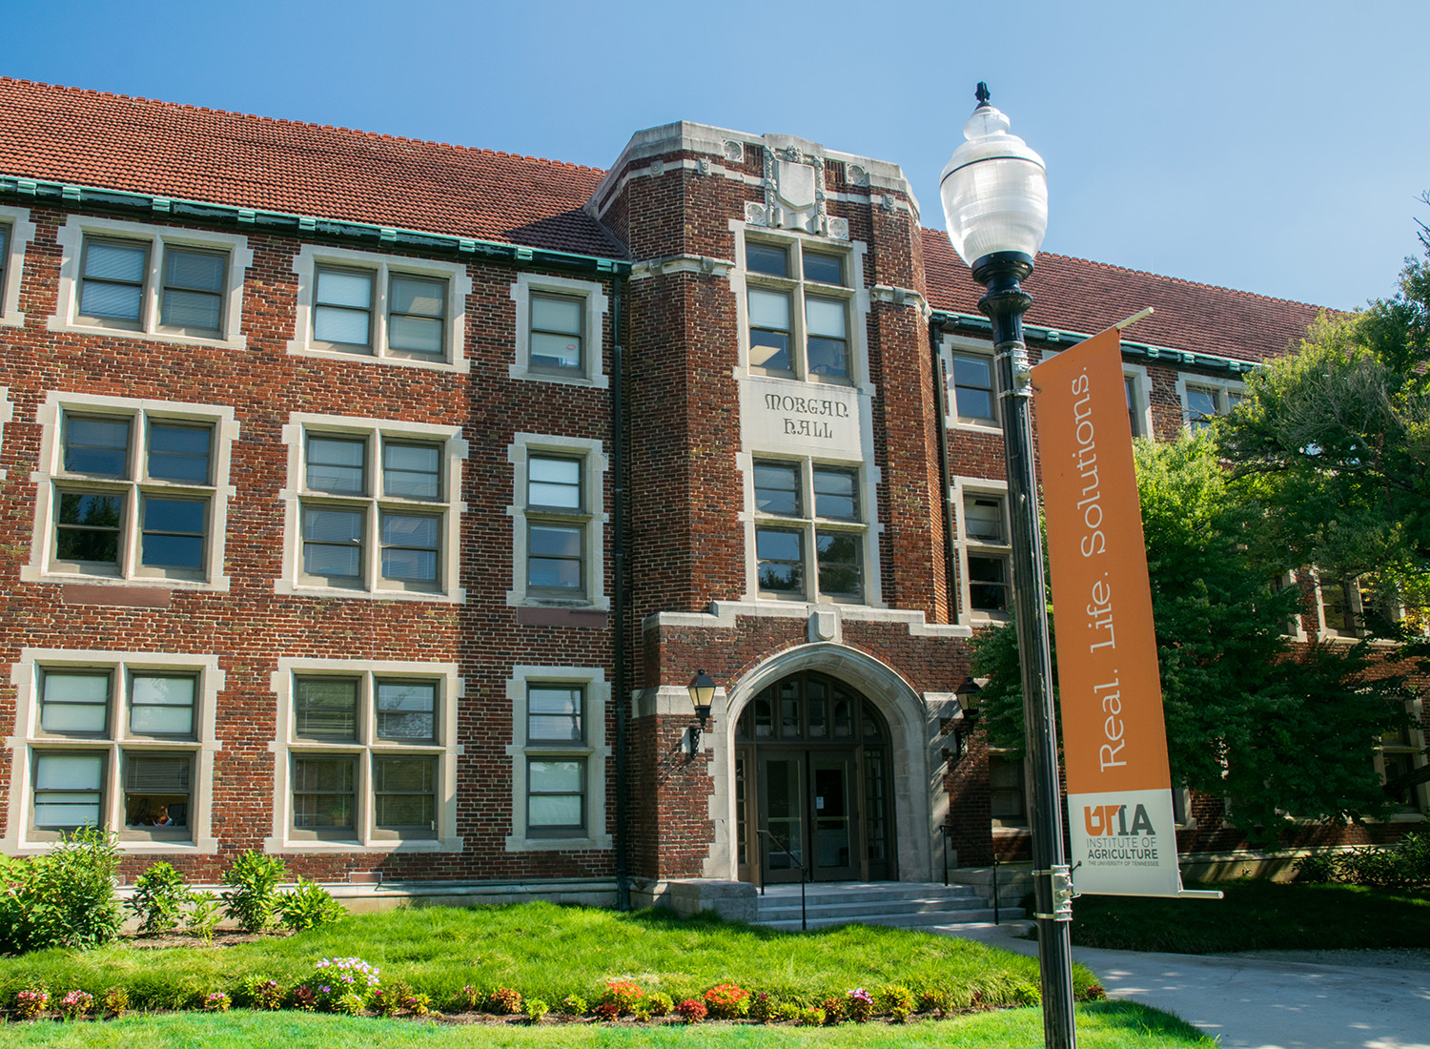
THE UNIVERSITY OF TENNESSEE INSTITUTE OF AGRICULTURE:
AN OVERVIEW

The UT Institute of Agriculture is truly at the core of the University of Tennessee land-grant mission of teaching, discovering and connecting. The Institute, through its colleges, research and education centers, and county extension offices, serves the people of Tennessee and beyond and is focused on finding solutions to some of our world’s most pressing issues. This work is based on the Institute’s four pillars: Advancing Academic Excellence, Delivering Discoveries, Promoting Hands-On Learning, and Serving Our Communities. Working with the University of Tennessee, Knoxville, the colleges are committed to providing undergraduate, graduate and professional educational programs in a diverse learning environment that prepares students to be leaders in a global society. Collectively, the Institute contributes to the economic, social and environmental well-being of all Tennesseans.

The Institute’s four major units are the College of Agricultural Sciences and Natural Resources, the College of Veterinary Medicine, UT AgResearch and UT Extension.

College of Agricultural Sciences and Natural Resources
The College welcomes students from across Tennessee, the nation and the world. The college has close to 1,500 undergraduate students engaged in 10 majors, 14 minors and 39 areas of focus. Demand for its programs has led to an enrollment increase of 86 percent since 2003 and overall enrollment growth of 40 percent over the past five years. Academic programs are in a variety of natural and social science-based disciplines that prepare students for careers in the food, fiber and natural resources systems. For students in the College of Agricultural Sciences and Natural Resources (CASNR), learning is personal and often hands-on. Student teams provide opportunities for self-directed study, leadership development, and a lot of fun. A new honors research and creative achievements program challenges students to excel. International study tours give graduates an edge in the increasingly connected world of global markets.
College of Veterinary Medicine
The College of Veterinary Medicine (CVM) is one of only 30 veterinary colleges in the nation and the only one fully accredited in Tennessee. Each year, the college admits approximately 85 applicants to the four-year program for the doctorate in veterinary medicine. It is also a national leader in creating a collection of virtual microscope slides students can access from the convenience of their personal computers. New services in equine sports medicine offer students opportunities, as does the expansion of the college's facilities. The College serves pet owners, zoos and the livestock industry, protects public health, enhances medical knowledge and generates economic benefits to the state and nation. Outreach programs engage citizens in learning programs that explore the animal-human bond.

UT AgResearch
AgResearch is an integral partner in teaching programs throughout the Institute. Our faulty conduct world-class research programs in a variety of areas including crop breeding and genetics, soil conservation, no-till crop production, cattle reproduction, wood product development, new food and safety techniques and plant disease and entomology research. Through AgResearch achievements, soil loss in one of the world’s most fertile regions has been reversed, saving producers money and protecting water quality; outstanding soybean varieties have been developed that are used as USDA checks; and scientists have achieved research breakthroughs that improve breeding success in animals. In addition to scientific impacts, AgResearch is also a key funding source for graduate assistantships and research opportunities that students undertake in their degree programs. Internships offer undergraduates unparalleled field experience. The unit's 10 research facilities serve as field laboratories for faculty and students, while allowing the public to evaluate research trials and experience gardens and arboretums.

UT Extension
UT Extension provides a gateway to the University of Tennessee as the outreach unit of the Institute of Agriculture. It is a statewide educational organization, funded by federal, state and local governments, that brings research-based information about agriculture, family and consumer sciences, and resource development, as well as 4-H youth education to the people of Tennessee where they live and work. Because Extension emphasizes helping people improve their livelihood where they are located, most Tennesseans have contact with UT Extension through their local county Extension agents found in all 95 counties. Extension agents are supported by area and state faculty as well as by the educational and research resources and activities of the United States Department of Agriculture (USDA), 74 land-grant universities, and 3,150 county units throughout the nation. The stated mission of the system is to help people improve their lives through an educational process that uses scientific knowledge to address issues and needs.

UT Institute of Agriculture
Whether it is 4-H youth, owners of animals treated by our veterinarians, students who are exceptionally well served and have a close relationship with their professors, homeowners helped by an extension specialist, or agricultural companies and Tennessee farmers with whom the Institute is engaged, we focus on a better Tennessee. From research of diseases in humans and animals to producing new plant cultivars for Tennessee, the Institute is focused on producing cutting edge science that creates real-life solutions for problems facing Tennesseans.

See Appendix I for information about our partnership with Oak Ridge National Laboratory, Appendix II for information about the Knoxville community and Appendix III for information about the State of Tennessee. For more information about the University of Tennessee Institute of Agriculture, please visit http://www.ag.tennessee.edu.

THE ROLE

The Institute of Agriculture is headquartered on the Knoxville campus of the University and has a strong presence in all 95 Tennessee counties. The primary responsibilities of the position are to promote academic excellence and to provide leadership and administration to the Institute. In addition, the Chancellor is responsible for planning, implementing and leading strong, progressive programs of excellence in the Institute, including UT Extension, UT AgResearch, the College of Agricultural Sciences and Natural Resources, and the College of Veterinary Medicine. The Institute has primary facilities in Knoxville and statewide facilities associated with ten research and education centers, four 4-H Centers, and three regional offices of UT Extension.

The Chancellor is expected to provide visionary leadership in strategic initiatives to enhance the standing of the University, budget planning and accountability, shared governance, enhancement of diversity and interculturalism, resource enhancement, engagement of the University with the wider community and other elements of administrative policy. The Chancellor establishes and maintains productive relationships on behalf of the Institute with state government, agricultural industries, veterinary organizations and professionals, forest and natural resources industries and agencies, the Tennessee congressional delegation and federal agencies. Specific duties include, but are not limited to:

- Articulate a strategic vision and long-term goals for the Institute.
- Provide direction and incentives for research, creative achievement and service.
- Foster interdisciplinary approaches to undergraduate and graduate education.
- Create innovative and effective programs across the four divisions of the Institute.
- Ensure that Extension services meet the agricultural and natural resources needs of the state.
- Ensure that veterinary clinical and diagnostic services meet the needs of the state.
- Nurture relationships with other University programs and with the Oak Ridge National Laboratory.
- Maintain a cooperative and mutually beneficial relationship with the chancellors of other UT campuses in the implementation of agricultural curricula and programs.
- Direct the recruitment, development and retention of excellent faculty, department heads and deans.
- Lead the Institute’s development activities.

QUALITIES AND QUALIFICATIONS

Education:
Requires an earned terminal degree and evidence of scholarly, professional, or creative achievement sufficient to qualify for tenure as a full professor in one of the units at the Institute; progressively more responsible administrative leadership in higher education or comparable leadership experience.

Experience:
Requires an understanding of the University’s mission as a public, research, land grant university; demonstrated knowledge of and a history of commitment to affirmative action, equal employment opportunity and diversity, and intercultural education; ability to represent the University to external audiences, including government and alumni groups; exceptional communication and development skills and the ability to work collegially with a wide variety of constituencies. Requires demonstrated deep and contemporary experience leading a complex and comprehensive organization; a personal history of teaching and research commensurate with faculty status at a major research university. Requires a broad knowledge of agriculture, natural resources, veterinary medicine and outreach activities. Requires excellent oral, written and other communications skills; ability to multi-task and the ability to travel frequently, sometimes out-of-state.

Skills:
The Chancellor will have significant knowledge and understanding of higher education. Specific skills include:
- demonstrated leadership skills and abilities.
- commitment to quality and integrity.
- a broad knowledge of agriculture, natural resources, veterinary medicine and outreach activities.
- demonstrated leadership and abilities in the administration of higher education agricultural and veterinary medicine programs, with substantive experience, preferably in a large public and/or land grant institution within a multi-campus environment.
- ability to mobilize volunteers and stakeholders for the enhancement of the university.
- demonstrated ability and skills in securing extramural funding.
- exceptional skills in communications and interpersonal relations.
- demonstrated ability to forge successful relationships and partnerships.
- knowledge of and commitment to affirmative action and equal employment opportunity.
- ability and willingness to delegate effectively and to hold direct reports accountable.
- skilled decision-maker, with transparency in decision-making and management.
- excellent oral, written and presentation skills; exceptional listening skills.
- ability to multi-task.
- ability to travel frequently.

Behaviors:
The Chancellor will exhibit qualities of emotional maturity, genuineness, self-confidence, common sense, judgment, fairness, creativity, discretion, decisiveness, political savvy, diplomacy, tact, resiliency, adaptability, courage of convictions, and tolerance for ambiguity. Demonstrated behavioral expectations include:
- Unquestioned integrity and trustworthiness.
- Commitment to the University’s mission and strategic plan, as well as missions and strategic plans for each campus/institute within the System.
- Ability to make good, consistent and fair decisions (based on fact and data).
- Ability to work with cross-functional teams and to foster teamwork.
- Ability to resolve complex issues.

PROCEDURE FOR CANDIDACY
Recruitment will continue until the position is filled. The search committee will review applications in mid-October. Information specifically on this search may be found at insert link here.

To make a referral, to express interest in the position or to obtain additional information, please contact:

Ashlie Czyz, Executive Recruiter
The University of Tennessee
105 Student Services Building
1331 Circle Park Drive
Knoxville, TN 37996-
Email: aczyz@tennessee.edu
Phone: (865) 974-1907

Please note that Tennessee prides itself on the transparency of its government, and all formal candidacies will be subject to public inquiry.

The University of Tennessee is an EEO/AA/Title VI/Title IX/Section 504/ADA/ADEA institution in the provision of its education and employment programs and services. All qualified applicants will receive equal consideration for employment without regard to race, color, national origin, religion, sex, pregnancy, marital status, sexual orientation, gender identity, age, physical or mental disability, or covered veteran status.

APPENDIX I — Partnership with the Oak Ridge National Laboratory

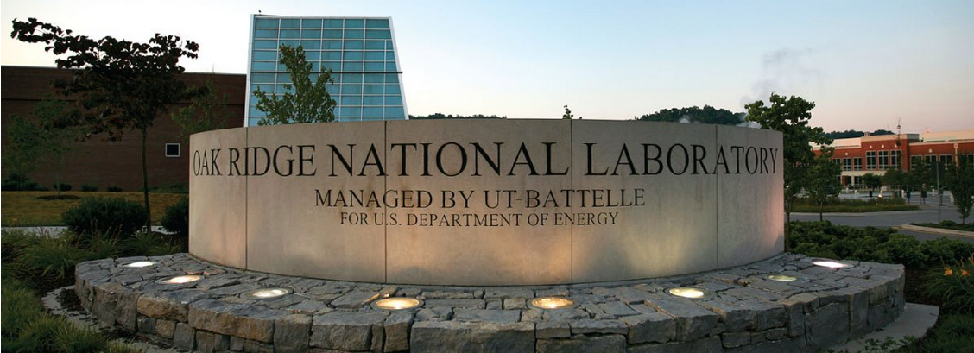

The UT System is a managing partner, through UT-Battelle, of Oak Ridge National Laboratory (ORNL) – home to the largest open-science research facility in the national laboratory system. This partnership provides UT a unique opportunity to be at the forefront of solving some of the nation’s and the world’s greatest challenges.

The UT-Oak Ridge Partnership, with a focus on computational science, neutron science, biological sciences, nanomaterials and advanced materials is an unparalleled resource for the state.

More about the UT-Oak Ridge Partnership is at: http://www.tennessee.edu/ornl.

APPENDIX II—The Knoxville Community



With a population at nearly 179,000, Knoxville is both the oldest and the third-largest city in the state of Tennessee; only Memphis and Nashville are larger. Nestled in the foothills of the Appalachian Mountains along the Tennessee River, Knoxville is a one-hour drive from Great Smoky Mountains National Park, the U.S. National Park Service’s most-visited site. Knoxville also is within a day’s drive or less to many major metropolitan areas, including Atlanta, Chicago, Washington, D.C. and the Atlantic coast. UT’s Neyland Stadium is one of the country’s largest sports venues.

Knoxville boasts a vibrant history, captured in the works of nationally renowned poets, writers and artists, including James Agee, Cormac McCarthy and Nikki Giovanni.

More about Knoxville and links to numerous related websites may be found at:
http://www.utk.edu/knoxville/.

APPENDIX III — The State of Tennessee
Tennessee is a state with more than 6.3 million people, four large metropolitan areas, two time zones, and an economy ranked* 17th-largest in the United States. While more Tennessee jobs and economic activity today are industrial or knowledge-based than agrarian, farming and agricultural production remain fundamental to the state’s economy. Major outputs include textiles, cotton, cattle, and electrical power – thanks to being home to TVA.

From the Mississippi River on the western border, to the Appalachian Mountains on the eastern border, Tennessee spans a distance of more than 400 miles. Major geographic and cultural diversity are evident from the delta and farm areas of the west, to the rolling hills surrounding Nashville in Middle Tennessee, to the mountainous landscape of East Tennessee.

The state’s four largest cities are Memphis, metropolitan area population: 1.3 million; Nashville, metropolitan area population: 1.5 million; Knoxville, metropolitan area population: almost 700,000; and Chattanooga, metropolitan area population: about 500,000.
Major corporations headquartered in Tennessee include FedEx, AutoZone, International Paper, all based in Memphis; Pilot Corp., Scripps Networks Interactive, and Regal Entertainment Group based in Knoxville; Eastman Chemical based in Kingsport; Nissan’s North American headquarters in Franklin; and the headquarters of Caterpillar Financial, Bridgestone-Firestone and HCA, all based in Nashville. A large Nissan manufacturing facility has been in Smyrna since 1982. In 2015, Volkswagen announced a $17.8 million expansion of its major manufacturing facility in Chattanooga.

The University of Tennessee maintains a presence in, draws students from and boasts alumni in each of Tennessee’s 95 counties. Collectively, the entire state is the campus, and overseeing all UT enterprises and maintaining relationships with the University’s numerous constituencies statewide is the responsibility of the UT System president.

*Source: U.S. Bureau of Economic Analysis 2015

